Do You Need Supplements?

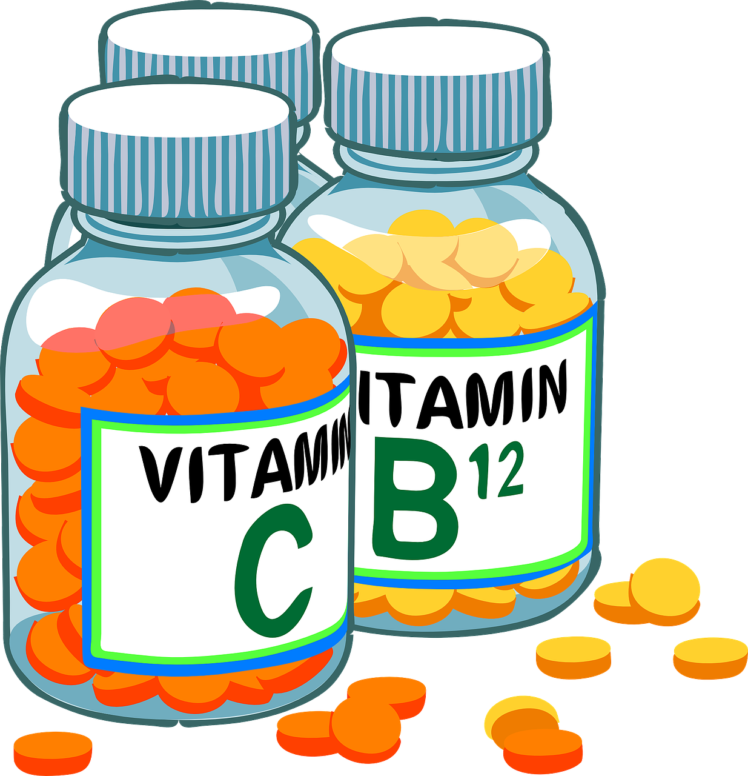
Many of us don’t get enough nutrition from the food we eat. In fact…

- 72% of individuals do not meet calcium needs
- 68% do not meet magnesium needs
- 41% are deficient in vitamin D
- 48% are lacking in vitamin C

Could this be YOU?

Always food first, but supplements may be needed when…
- Eating foods that are nutrient depleted
- Needing more than you can get from food (even with a well-balanced diet)
- Consuming a specialty diet, such as vegetarian or vegan
- You have nutrient imbalances (there are lots of reasons why!)

Selecting supplements requires expertise
- Don’t take the chance with recommendations given by untrained store clerks
- A less expensive supplement is not always your best choice (you often get what you pay for)
- Less desirable added ingredients (like sugar, hydrogenated oils, etc.) should be avoided
- For best support, supplements need to be personalized to your specific needs
- Some supplements can interact with medications and lead to serious health problems

Supplement know-how
- Not everyone should take a general multivitamin, even if they need many of the nutrients. Do you know why?
- When you take calcium, do you know which 3 other vitamins you must have enough of?
- The same nutrient, like zinc, can come in several different forms. Which one is best for you?
As a Functional Medicine Nutritionist, I offer expert advice to answer all your questions. I’ll determine your specific needs and create a personalized regimen that’s safe and effective using professional-grade supplements to support your optimal health and vibrancy!

Schedule Your Personalized Consultation TODAY!
Your Logo HERE
Your Contact Information

©2021 COPYRIGHT. Nutriwellness, Inc/ Next level Functional Nutrition (Used with permission)

