What’s the Deal with EMFs?
Are you confused about all the talk on electromagnetic radiation exposure? Should you be worried about this? Well, much of the science is quite contradictory. But that’s why a functional nutritionist like me can help!

What is an Electromagnetic Field (EMF)?
You may or may not have heard of the term electromagnetic field before; also called electromagnetic radiation. These fields are a wide range of frequencies or wavelengths that can interact with the body in various ways that are beneficial and harmful. There are two main types of EMFs. The first is naturally occurring which involves the earth and the sun – this is what’s good. The second type is man-made. This includes electrical machines and devices that create electromagnetic frequencies on their own. Essentially, anything that you can plug in has an electromagnetic field, and this is the area of concern. We all know x-rays can be dangerous, but should we be concerned with our internet and cell phones? Some experts warn – yes!

Why Do We Care About EMFs?
Research on EMFs is conflicting, especially when it comes to the health impacts. However, some people are more sensitive to EMFs than others. Some of the reported health effects are:

- Insomnia
- Headache
- Fatigue
- Depression
- Hearing dysfunction
- Vision problems
- Trouble concentrating
- Dizziness
- Memory issues
- Anxiety
- Irritability
- Nausea

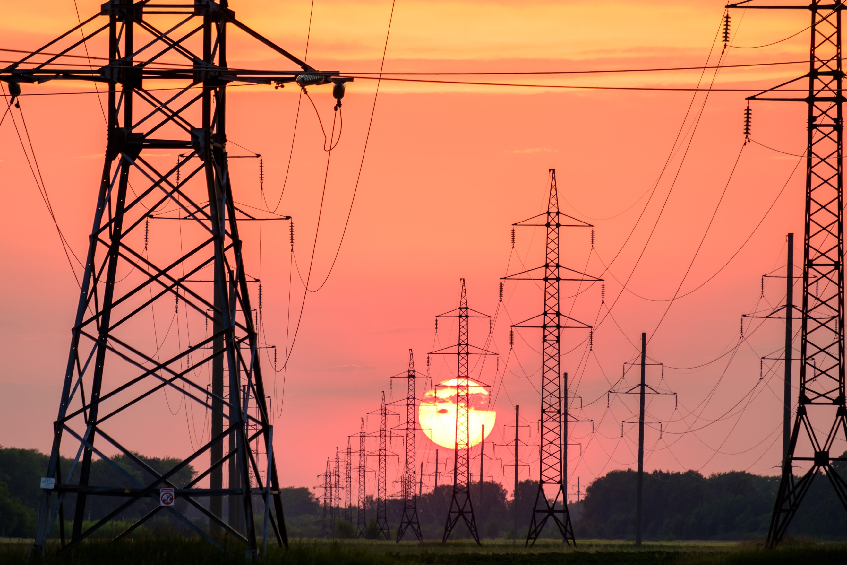
Sources of EMFs

- Cellphones
- Microwaves
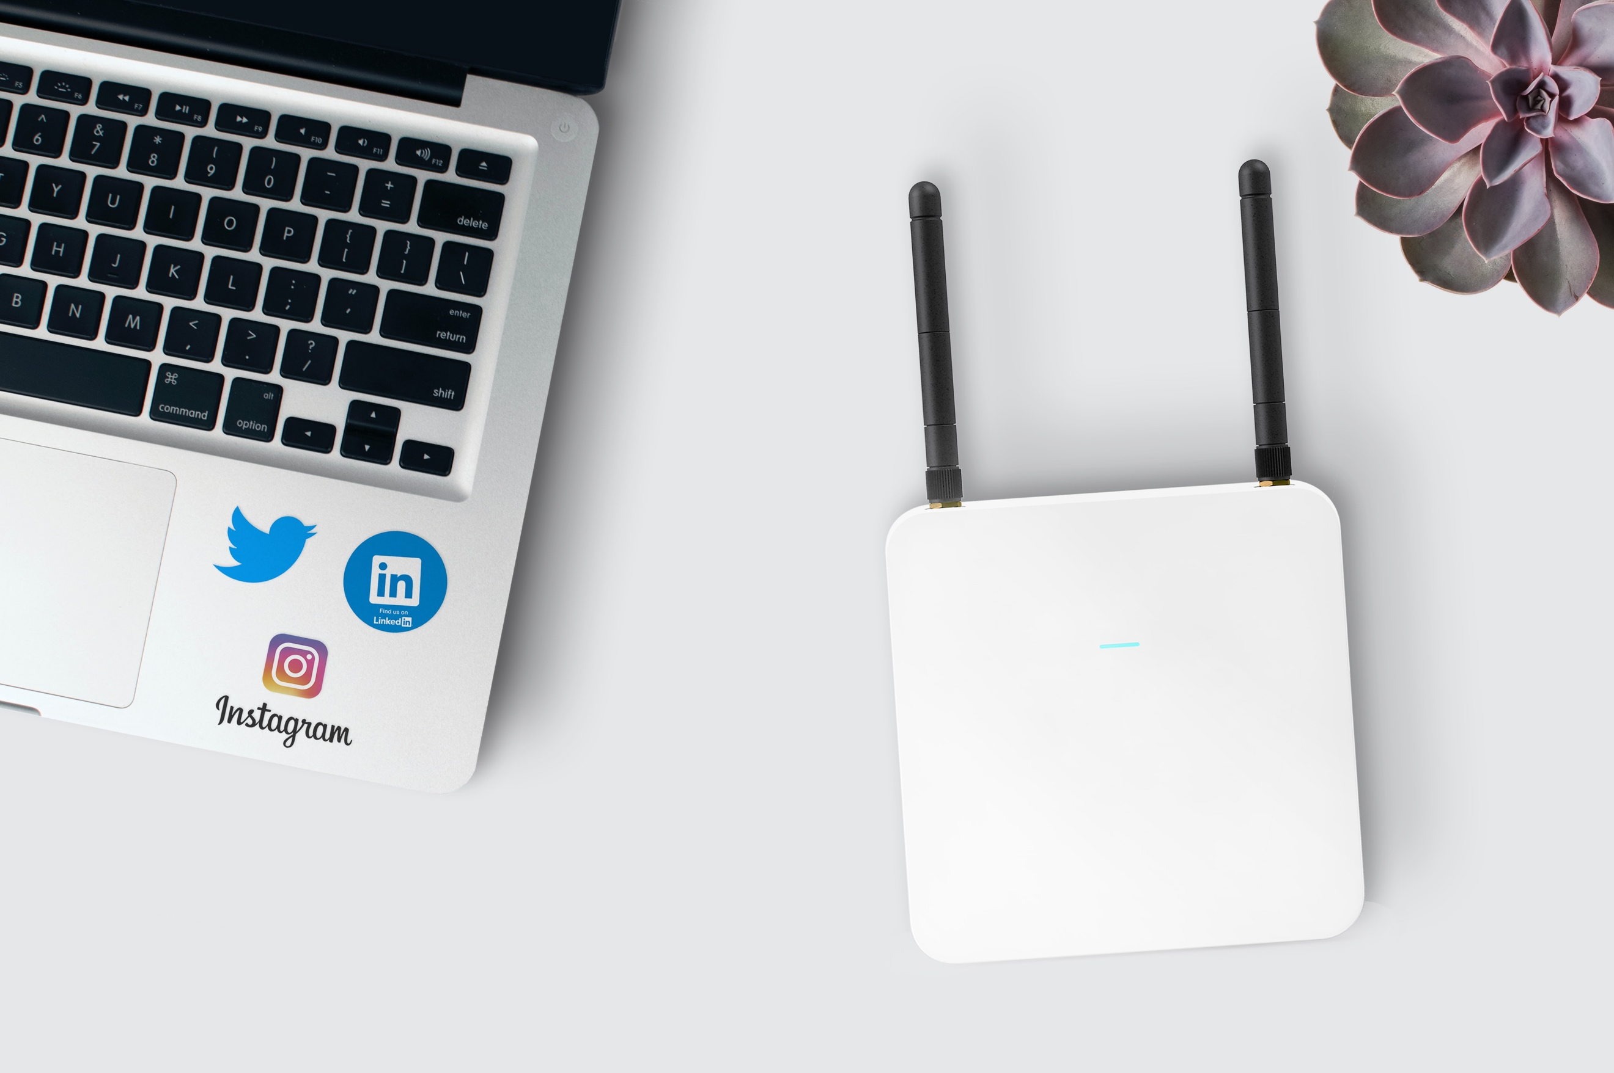
- Computers
- WiFi routers
- Smart TVs
- Smart watches
- Electric blankets
- Hair dryers
- Power lines
- Refrigerators
- Cell phone towers
- Airplanes

What’s the Impact of 5G Wireless?
There are many advantages of advancing technology, but some say it could be impacting our health without us even knowing. There’s no faster growing technology than cellular, especially 5G. So, what is 5G and should you be concerned?
- 5th generation of mobile broadband (another source of EMFs) allows faster download and upload speeds and works across a wider range of radio frequencies
- Used in cell phones and towers, home broadband and computers, city infrastructure, smart homes, electric and hybrid cars, and some agriculture systems, they are supposed to make our lives easier.
Is the latest and greatest technology worth the increased EMFs that come with it?
- Suspected health effects – increased cancer risk, genetic damages, changes in the reproductive system, learning and memory problems, neurological disorders, and other negative impacts. Again, some may be affected more than others.

How to Reduce Your EMF Exposure
- Do you know how to safely use your phone or other technology? For example, never put your phone up to your ear or carry it in your pocket. Some prefer to turn off their wireless while they sleep. There’s so much more to know!
- While there are many EMF shielding products on the market, there are equally as many scams. Which ones are actually valid?
- Certain foods can reduce inflammation as a result of EMFs. Which foods are the best?
- There are various practices to reduce the impact of EMFs, such as earthing or grounding. Do you know what this is and how to practice this correctly?
- Some plants absorb EMFs. What ones are the best to have in your home?
Do you want to know more about EMFs and how to protect you and your family?
Contact me for a consult now!
Your Logo

